**Haiku**

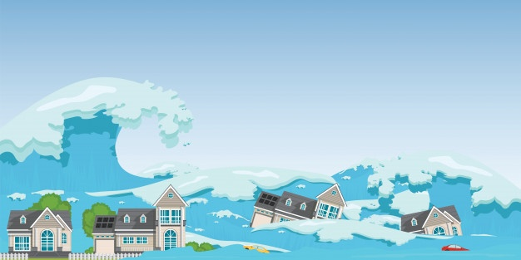

By Willie Lam (6 Hope)

Title: Tsunami

Strong and violent,

Bringing fierce floods everywhere,

Breaks things in a flash.